A

TITLE:
A TRIBUTE TO
MUHAMMAD ALI JINNAH

(A LAB PROJECT)



COURSE
GROUP MEMBERS
COLLABORATION WITH
COURSE INSTRUCTOR

RAMSHA KHALID
TA: MUDDASIR IQBAL

SPECIAL COLLABORATION WITH ALZARAAN SOFTWARE HOUSE

- FASIH ULLAH (2025-CS-243)
- LAIBA AKRAM (2025-CS-249)
- SAHAR RABBANI (2025-CS-287)
- HAMZA ZAHID (2025-CS-264)
- M. ABUBAKAR (2025-CS-254)

THIS IS A FINAL GROUP PROJECT OF 1ST SEMESTER FOR THE AICT LAB.
SITE STRUCTURE AND NAVIGATION

- To honor Quaid-e-Azam Muhammad Ali Jinnah through a digital tribute.
- To provide reliable historical information.
- To design a simple, sleek and user-friendly website.
- The scope is limited to informational content and does not include user interaction such as login systems or databases.

- Home Page: Introduction with Quaid-e-Azam’s.
- About Him: Early life, education, and political journey.
- Highlights: His famous quotes, images related to Quaid, history bears witness and how the world remembers him.
- Documentary: A link which provides access to a video documentary “Muhammad Ali Jinnah and the history of India and Pakistan”.

PROJECT OBJECTIVES & SCOPE

This project is a tribute website dedicated to Quaid-e-Azam Muhammad Ali Jinnah, the founder of Pakistan. The purpose of the website is to educate users about his life, leadership, and contributions to the creation of Pakistan through a clean, informative, and visually appealing web interface. The site focuses on simplicity, accessibility, and
historical accuracy while presenting key events, quotes, and achievements.
EXECUTIVE SUMMARY
DESIGN CHOICES

- Fonts: Fairplay display for headings. Eb Garamond for body.
- Colors: Color palette used for this website is a “Neutral Dark Autumn palette” to keep it simple

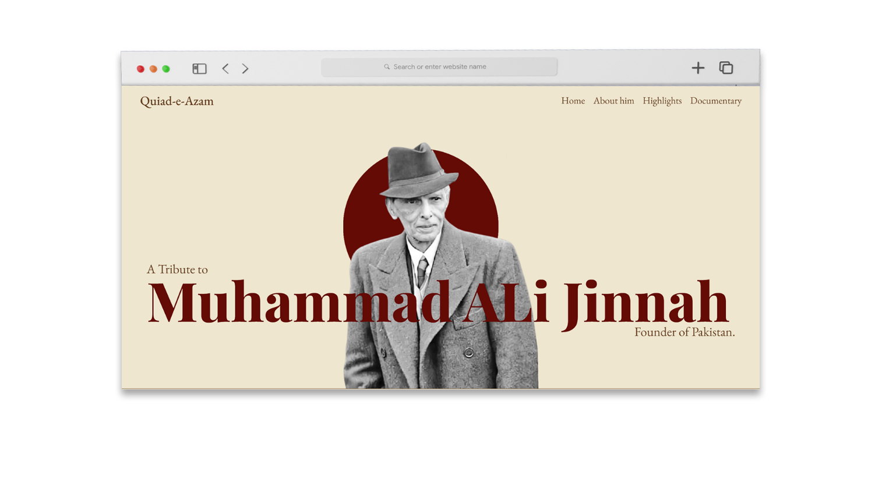
SCREENSHOT OF THE “HOME” PAGE

Images: Public domain images of Quaid-e-Azam.
Content Sources: History textbooks and reputable online historical sources.
Documentary URL: The documentary URL is copied from a YOUTUBE video.
ASSESTS USED

SCREENSHOTS OF THE WEBSITE

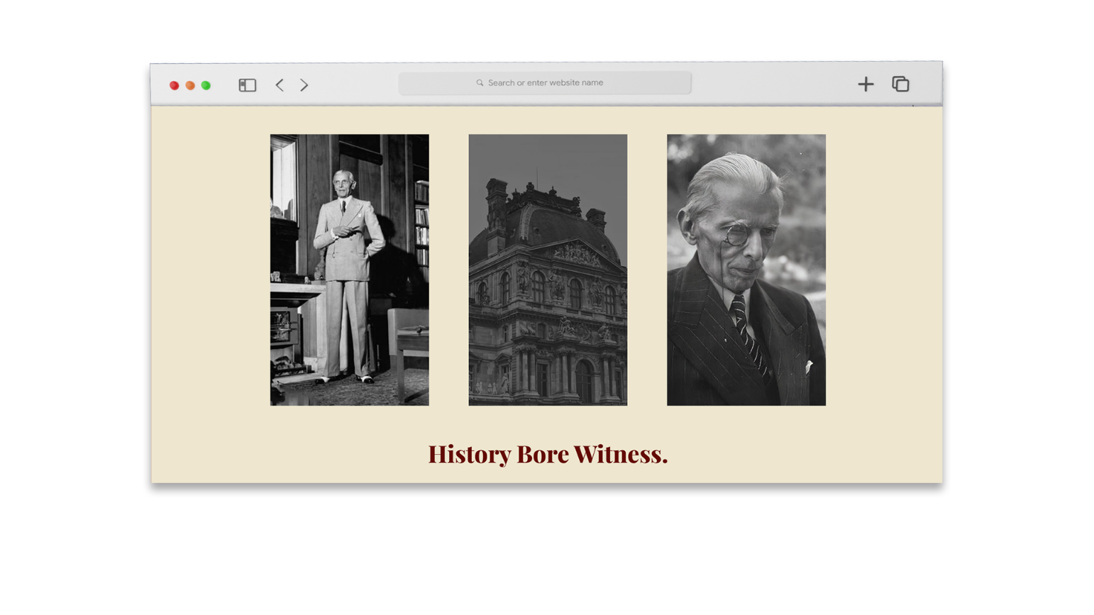
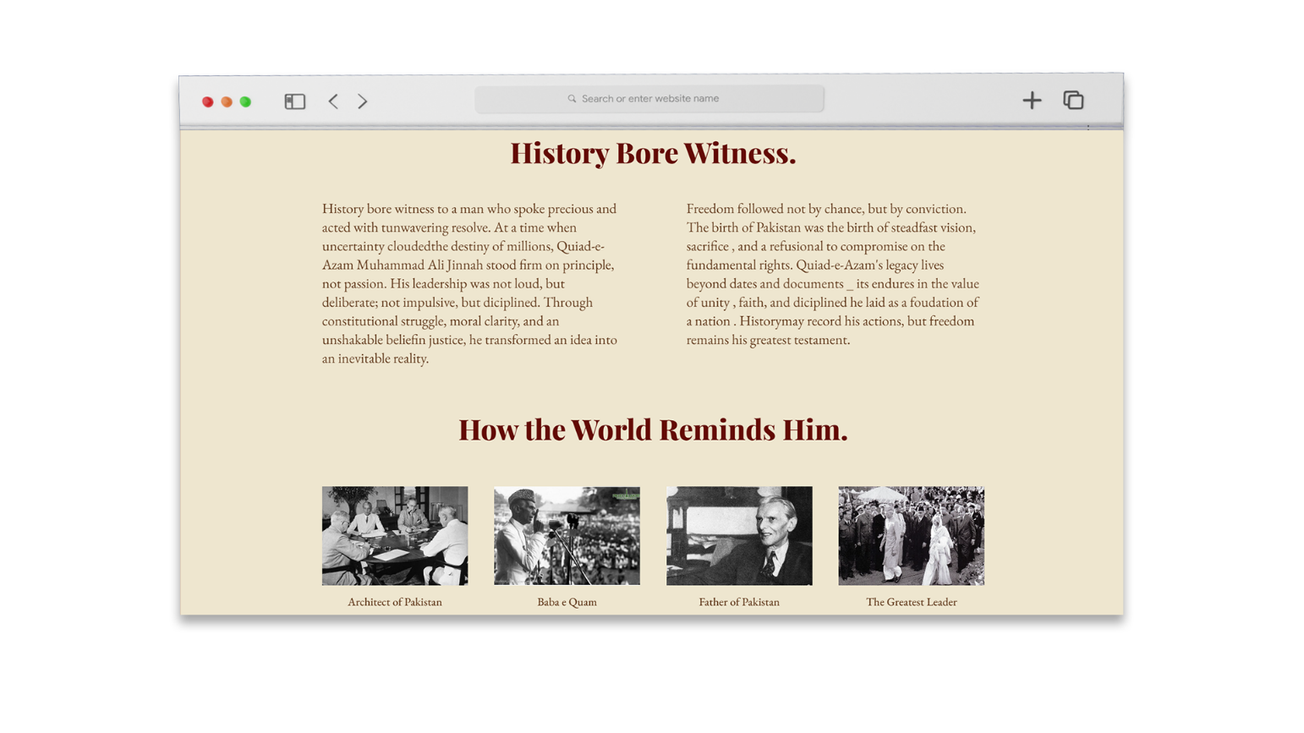
HOW TO RUN THE WEBSITE

The website can be opened locally by running the HTML file in any modern web browser. For publishing, the site can be uploaded to platforms such as GitHub.
SHORT BIOGRAPHY OF QUAID-E-AZAM

Quaid-e-Azam Muhammad Ali Jinnah (1876–1948) was the founder of Pakistan and one of the greatest leaders of the 20th century. Born in Karachi, he was a brilliant lawyer, a powerful orator, and a principled statesman. Through his unwavering determination, honesty, and political wisdom, he led the Muslims of the subcontinent in their struggle for an independent homeland.
Jinnah believed deeply in constitutionalism, democracy, and equal rights for all citizens. Despite immense challenges, his visionary leadership resulted in the creation of Pakistan in 1947. As the nation’s first Governor-General, he worked tirelessly to lay the foundations of a just, democratic, and progressive state. Quaid-e-Azam is remembered as a symbol of unity, faith, and discipline, and his legacy continues to inspire generations of Pakistanis.
Quaid-e-Azam Muhammad Ali Jinnah spent his last days in poor health after devoting his life to the creation of Pakistan. Despite his illness, he continued to work for the betterment of the new nation. He passed away on 11 September 1948, leaving behind a great legacy and a country built on his vision and leadership.

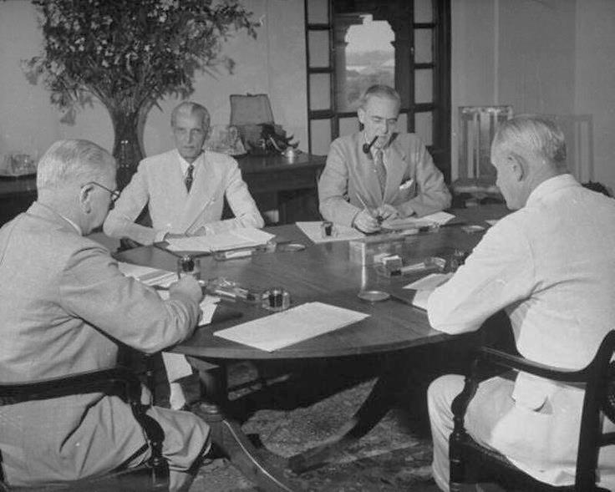
END.

This project was created as a tribute to Quaid-e-Azam Muhammad Ali Jinnah, honoring his visionary leadership and lifelong struggle for the creation of Pakistan. Through this website, we aimed to present his life, achievements, and values in a clear and manner while applying fundamental web design principles. The project enhanced our understanding of website planning, content organization, and visual design. Most importantly, it allowed us to reflect on the sacrifices and ideals of our national hero, inspiring us to uphold unity, faith, and discipline in our own lives.
REFLECTION

